**1DAILY ONLINE ACTIVITIES SUMMARY**

|  |  |  |  |  |  |  |  |  |
| --- | --- | --- | --- | --- | --- | --- | --- | --- |
| **Date:** | **17-7-2020** | | | | | **Name:** | **poojashree** | |
| **Sem & Sec** | **8th sem A sec** | | | | | **USN:** | **4al16cs065** | |
| **Online Test Summary** | | | | | | | | |
| **Subject** | |  | | | | | | |
| **Max. Marks** | |  | | **Score** | | |  | |
| **Certification Course Summary** | | | | | | | | |
| **Course** | **Introduction to cyber security** | | | | | | | |
| **Certificate Provider** | | | **Great learning academy** | | **Duration** | | | **5.5hr** |
| **Coding Challenges** | | | | | | | | |
| **Problem Statement:**  **Program to get the indexes of a particular characters in C** | | | | | | | | |
| **Status:completed** | | | | | | | | |
| **Uploaded the report in Github** | | | | | **yes** | | | |
| **If yes Repository name** | | | | | **Poojashree** | | | |
| **Uploaded the report in slack** | | | | | **yes** | | | |

**Online test**

**----------no marks -----------**

**Certification course**

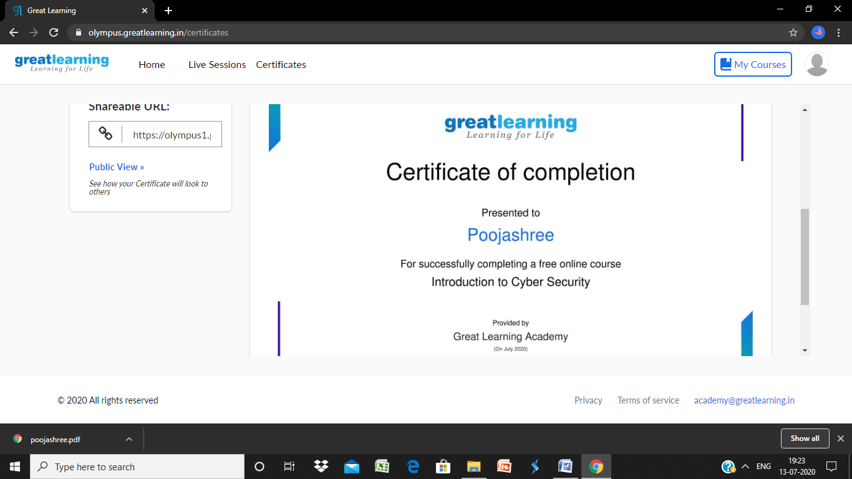

**Coding**

**Program 1**

**#include <stdio.h>**

**int main()**

**{**

**char str[30],ch;**

**int ind[10],loop,j;**

**printf("Enter string: ");**

**scanf("%[^\n]s",str);**

**printf("Enter character: ");**

**getchar();**

**ch=getchar();**

**j=0;**

**for(loop=0; str[loop]!='\0'; loop++)**

**{**

**if(str[loop]==ch)**

**ind[j++]=loop;**

**}**

**printf("Input string is: %s\n",str);**

**printf("Indexes: ");**

**for(loop=0; loop<j; loop++)**

**printf("%d \t",ind[loop]);**

**return 0;**

**}**